|  |  |
| --- | --- |
| Course Number | ELE532 |
| Course Title | Signals and Systems I |
| Semester/Year | F2022 |
| Instructor | Dimitri Androutsos |
| TA Name | Sarina Taki |
| Section No. | 08 |
| Submission Date | 13-November-2022 |
| Due Date | 14-November-2022 |

|  |  |  |
| --- | --- | --- |
| Student Name | Student ID | Signature* |
| Ahmad El-Gohary | 501011852 |  |

*By signing above, you attest that you have contributed to this submission and confirm that all work you have contributed to this submission is your own work. Any suspicion of copying or plagiarism in this work will result in an investigation of Academic Misconduct and may result in a “0” on the work, an “F” in the course, or possibly more severe penalties, as well as a Disciplinary Notice on your academic record under the Student Code of Academic Conduct, which can be found online at:

http://www.ryerson.ca/content/dam/senate/policies/pol60.pdf

Contents

Introduction 3

Lab Results 3

Conclusion 26

# Introduction

The objective of this lab is to learn how to use Fourier series in the analysis and synthesis of periodic signals while continuing to learn how to use Matlab effectively.

# Lab Results

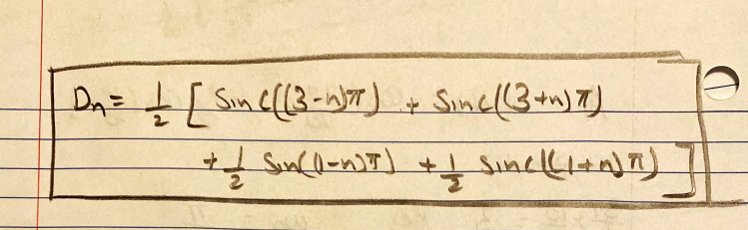

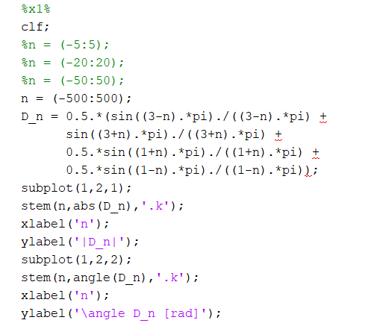

b)

c)

d)



X1(t):

X2(t):

# Conclusion

B1:

B2: The main difference between the coefficients of x1 and x2 is x1 has 4 distinct coefficients while x2 has infinite coefficients. Also, x1 is made of sinc functions while x2 is made of sin functions

B3: x3 has smaller fundamental frequency compared to that of x2

B4: x4 is x2 shifted thus D0 is 0.5

B5: for x2 as number of coefficients increase the graph would look more accurate however for x1 there is only 4 discrete coefficients so it will not make a difference

B6: for x2 and x3 we would need an infinite number of coefficients to perfectly reconstruct the graphs however for x1 we only need the 4 distinct coefficients

B7: no since it will vastly depend on the signal. if it has infinite coefficients such as x2 and x3 it would take up a lot of space and would be impossible to perfectly reconstruct it, but if it is like x1 then it is possible, but it is not recommended as it will still need more time to reconstruct it than just save the function and run it.